Beta Kappa BANTER

May 2023-August 2023

Mission Statement: The Delta Kappa Gamma Society International promotes professional and personal growth of women educators and excellence in education.
The Fourth Purpose of the Delta Kappa Gamma Society will be: To initiate, endorse, and support desirable legislation in the interests of education and of women educators.

PRESIDENT’S MESSAGE
Greetings, Beta Kappa Sisters!
Summer is just around the corner, and as I approach the end of my first year as president, I can honestly say it’s been a lot of fun. And we have more to come! After a successful planning meeting with the Executive Board on May 6th, we have set up a whole host of fun experiences in the year to come.
First and foremost is our joint picnic on June 14th at the Apple Museum in Biglerville. It’ll be Flag Day as well, so be sure to wear your red, white, and blue. Frank Hancock, the professional dancer who has participated in the local Dancing With the Stars for years at the Majestic Theater will be taking us through some fun line dancing. I had the privilege of taking quite a few dancing lessons from Frank in the past, and he is very laid-back and entertaining. We are sure to have a great time. The cost for the picnic will be just $5 along with a dish to bring to share. I’ll be baking again and provide dessert.
Next year’s programs are also going to be fun. We’ll be meeting at Chambersburg Perkins on the morning of September 9th where I will share some of my experiences from my mission trip to a school for abused and neglected girls in Bolivia. November will be a wellness topic, and we will be meeting on the east side, probably Fairfield or Gettysburg. More details on that to come. January 20th will be another Executive Board meeting at the Apple Bin in Biglerville, snow date the following week. And for our spring meeting, we are looking to set up a visit to the new museum at the Adams County Historical Society.
Don’t forget our service projects are coming up, too. We’ll be doing the Salvation Army bell ringing for an evening in December, and we’ll do another Hope Walks afternoon in January or February to paint the shoes for braces for children with club feet.
I have several reminders: Create or update your MY DKG account on the international website, www.dkg.org; join the PA DKG Facebook group; and don’t forget to be on the lookout for new members. Both State President Eileen Little and I have membership as our biennial goal.
Put on your dancing shoes, and I’ll see you on the 14th of June!
Laura Young

******PA Convention News******

The PA State Convention will be held at the Wyndham Resort and Convention Center in Lancaster, PA, from Wednesday, June 21st to Friday, June 23rd. The resort is perfect for a mini family vacation while the convention is on. Dutch Wonderland is across the road, outlets are adjacent and there are other activities such as golf available. The resort also is not far from The American Music Theater and the Sight and Sound Theatre. The convention will be preceded by the Purposeful Seminar this year. The speaker for the convention luncheon will be Kim Kluxen Meredith, author of the book, Listen for the Whispers, Coping with Grief & Learning to Live Again. Our International Guest will be Susan Perkins, SW Regional Director. Registration information is available online. Late fees may apply so check it out today!!!!
***************************************
DUES OF $85.00 ARE DUE TO KRISTINE REYNOLDS BY JUNE 15! CHECKS PAYABLE TO Beta Kappa.
May
10-Peg Lady
14-Frances Bassett
25-Louise Garverick
June
6-Karen Locke
8-Lorraine Junkin
13-Tammy Deardorff
19-Jill Miller
July
6-Barbara Montgomery
August
11-Brenda Newman
17-Marge Keller
25-Sally Becker
22-Laura Young

News About Our March Meeting
On March 25, 2023 Beta Kappa members met at the Waynesboro Country Club for our spring meeting and luncheon. Our presenter, local educator and author, was Annalise Grey (aka Anne Gageby). Annalise is the writer of three poetry anthologies, several novels in verse, and Gettysburg After Dark-True Experiences of a Ghost Guide. Her current position is the Environmental Education Manager at Strawberry Hill Foundation, Inc. located at Mount Hope in Fairfield. She shared with us how she connects the community with educational opportunities while inspiring environmental stewardship. You can access additional information about the work she is doing through strawberryhill.org. A delicious lunch and fellowship were enjoyed by everyone! Thank you, Jill Miller, for your time and energy arranging this meeting. We made it through without snowflakes…just a few raindrops!
______________________________

International Website:
Pennsylvania State Website:
https://dkgpa.weebly.com
Beta Kappa Website:
https://betakappapa.weebly.com

+++++++++++++++++++++++++++++++++++++++++++++++
2022-2024 Biennium Officers:
President-Laura Young
First Vice Pres.-Fran Ruda-McDermott
Second Vice Pres.-Liz Fair
Recording/Corresponding Secretary-Tammy Deardorff
Treasurer-Kristine Reynolds
Parliamentarian-Jill Miller
IMPORTANT DATES TO REMEMBER
June 14, 2023- 4:30 PM Beta Kappa/Omega Picnic, Patriotic Theme, Apple Museum, Biglerville, PA
Beta Kappa dues due June 15 to Kristine Reynolds (payable to: Beta Kappa)
June 21, 22, and 23, 2023- PA State Convention, Lancaster, PA
September 9, 2023- General Membership AM Meeting, Perkins, Chambersburg, PA
November 11, 2023- General Membership AM Meeting, LTBA on East Side
January 20, 2024- Executive Committee Meeting, Apple Bin Restaurant, Biglerville, PA (snow date-January 27)
March 9, 2024-General Membership Meeting, LTBA
April 2024- Birthday Brunch, LTBA

+++++++++++++++++++++++++++++++++++++++++++++++
Special Committee Chairpersons 2022-2024
Communications: Deborah Yargar-Reed
Finance: Marge Keller
Historical Records: Kristine Reynolds, Bev Utz
Membership: Liz Fair
Newsletter: Tammy Deardorff, Brenda Newman
Nominations:
Scholarship: Sally Becker, Carol Hozman
Welfare: Gayle Griffie, Jill Miller
U.S. Forum/Legislative: Karen Locke
World Fellowship: Peg Lady
************************************ ***********
It’s Time to…….
Wear your dancing shoes to the June 14th combined picnic of the Beta Kappa and Omega Chapters! See you “rain or shine” at The Apple Museum Pavilion, Biglerville, PA. Start time is 4:30 PM with dinner beginning at 5 PM. A $5.00 fee will cover any costs associated with the location and entertainment. Bring a dish (determined by the letter of your last name) and wear your RED, WHITE, and BlUE!!! See (separate document) flyer for more information!

***********************************
DID YOU KNOW?
Members may choose to return their Key Pin to the chapter “when they can no longer wear it”. Below is a form which you may use to let your family know you would like to return your pin to your Beta Kappa Chapter.
++++++++++++++++++++++++++++++++++++
To My Family/Friends,
This is my Delta Kappa Gamma Key Pin. I have worn it with pride since my initiation. When I can no longer wear it, please return it to:
Beta Kappa Chapter or
PA State Organization
To get the name and address of my Chapter’s current president, please contact:
The Delta Kappa Gamma Society International, 12710 Research Blvd. Ste 230, Austin, TX 78767-1589 tel: 512-478-5748, 888-762-4685
Date: _____________________________
Signature: _________________________
++++++++++++++++++++++++++++++++++++

Remember- Old friends are like sneakers-always comfortable. Lindsey, Age 12

Photo Gallery…
Beta Kappa Meeting April 2023
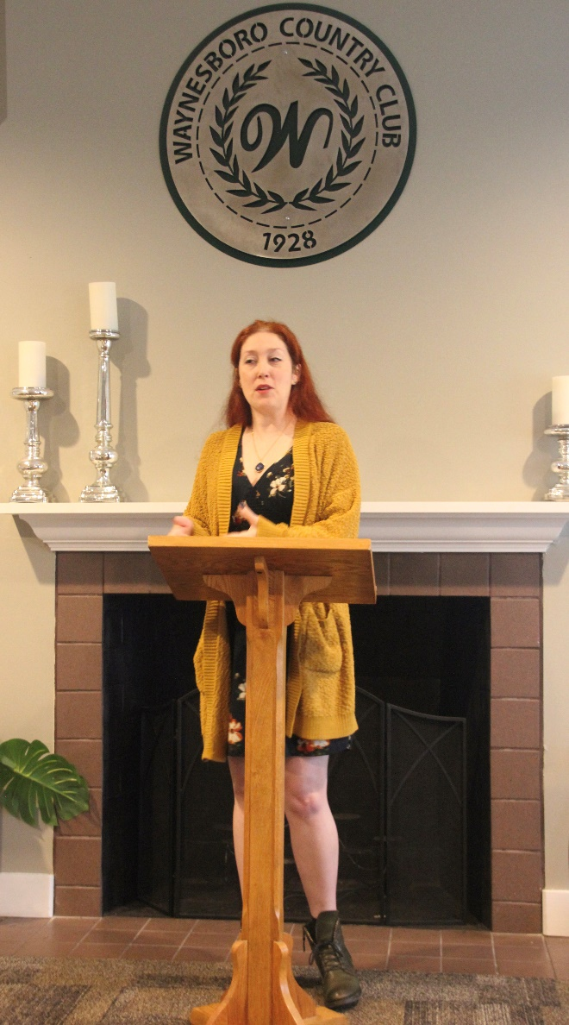Annalise Grey (aka) Anne Gageby-Presenter

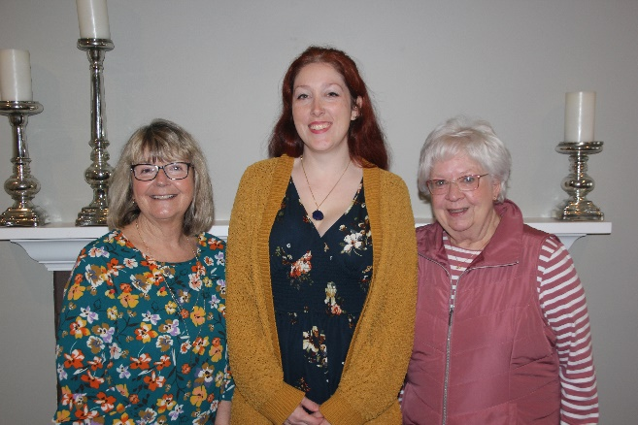
Tammy Deardorff, Annalise Grey, and Louise Garverick
Annalise is a past student of Tammy and Louise.
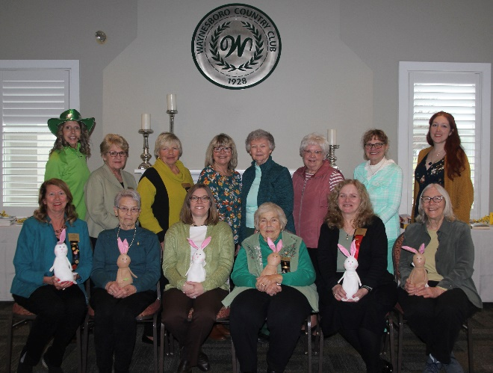
Beta Kappa Members-
Waynesboro Country Club
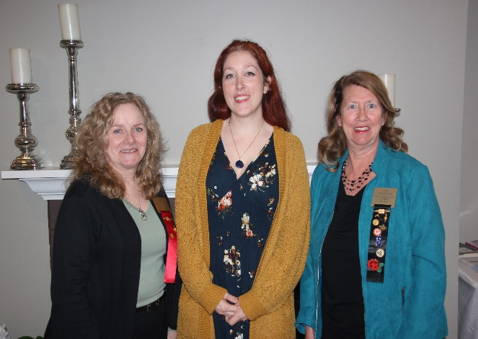
Laura Young, Annalise Grey, and Jill Miller

