Beta Kappa BANTER

February 2023-April 2023

Mission Statement: The Delta Kappa Gamma Society International promotes professional and personal growth of women educators and excellence in education.
The Third Purpose of the Delta Kappa Gamma Society will be: To advance the professional interest and position of women in education.

PRESIDENT’S MESSAGE
Greetings, Beta Kappa Sisters!
Spring is right around the corner, and we have a lot going on – our spring meeting at the Waynesboro Country Club, the Creative Arts Retreat, and our combined chapter picnic in June followed by the State Convention.
The State Convention this year will be held at the Wyndham Resort and Convention Center in Lancaster, PA, from Wednesday June 21st to Friday June 23rd. State President Eileen Little stressed during our recent Zoom meeting that the resort is perfect for a mini family vacation while the convention is on. Dutch Wonderland is across the road, outlets are adjacent and there are other activities such as golf available. The resort also is not far from The American Music Theater and the Sight and Sound Theatre. The convention will be preceded by the Purposeful Seminar this year, so those who would like to do that need to plan to register for Tuesday through Friday. More details on that are yet to come. The speaker for the convention luncheon will be Kim Kluxen Meredith, author of the book, Listen for the Whispers, Coping with Grief & Learning to Live Again. Our International Guest will be Susan Perkins, SW Regional Director. Registration for the convention is not yet up, but keep checking the state website (https://dkgpa.weebly.com) for that in the next couple of months
Registration for the Creative Arts Weekend is on the website right now. With everything from painting to quilting and from mahjong and swimming, it is sure to be an enjoyable weekend. The activities are posted with the registration.
I again want to thank all those who participated in our two service projects. The Salvation Army bell ringing in December garnered several pots full of money for their cause. And the Hope Walks service project is detailed below. Several who were there thought it would be fun to do again next year, so look for more on that in the future.
I have several reminders: Create or update your MY DKG account on the international website, www.dkg.org; join the PA DKG Facebook group; and don’t forget to be on the lookout for new members. Both State President Eileen Little and I have membership as our biennial goal.
I hope to see you at the spring meeting in March!
Laura Young
HOPE WALKS Service Project………
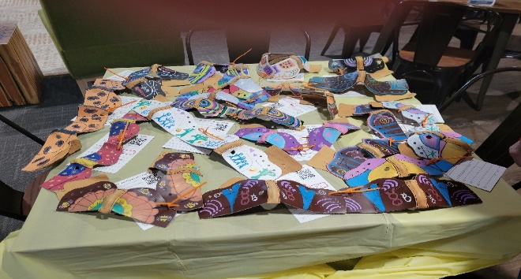
A BIG “thank you” to all who donated and/or attended our HOPE WALKS service project. We raised $285.00 for club foot children and painted numerous leathers that will be made into shoes.

Congratulations to Kristine Reynolds! Kristine received the nomination for our PA State Organization 2nd Vice-President’s position.

February
18- Jennifer Sauble
21-Deborah Yargar-Reed

March
27-Gayle Griffie

April
4-Joanne Shorb
13-Carol Hozman
16-Amy Gorman
19-Ann Ratay
22-Laura Young

News About Our March Meeting
It’s time to “Shake Your Shamrocks”, wear something green, and celebrate a special Spring awakening! Our March 25, 2023 Beta Kappa Membership Meeting will be held at the Waynesboro Country Club, 11000 Country Club Road, Waynesboro, PA at 10:00 AM. Our presenter, will be local educator and author, Annalise Grey (aka Anne Gageby), writer of three poetry anthologies, several novels in verse, and Gettysburg After Dark-True Experiences of a Ghost Guide. Annalise’s current position is the Environmental Education Manager at Strawberry Hill Foundation, Inc. located at Mount Hope in Fairfield. She’s looking forward to sharing with you how she connects the community with educational opportunities while inspiring environmental stewardship. You can access additional information through strawberryhill.org. Annalise will also have her books available for sale and autographs.
Our Irish-themed luncheon will feature Guinness Marinated Pork Loin, Parsley Potatoes, Sweet Peas, Spring Salad with a choice of dressings, Rolls and Butter, Mint Dessert, and selected beverages for a cost of $20.00 inclusive of tax and gratuity. Please make checks out to Jill Miller and RSVP by March 14th to Laura Young for an exact count by utilizing the enclosed mailing found at the end of the Beta Kappa Banter.
I’m also encouraging you to “Bring a Book and Take a Book” as has been our membership’s tradition to share with others. A table will be set up for display purposes and any leftover books will be donated to the Waynesboro Alexander Public Library. Keep cozy and cuddle up with a great book! And why not consider bringing a friend to join us for the Spring Beta Kappa Membership Meeting at the Waynesboro Country Club?
Shine with strength through sisterhood,
Jill Miller, Past President
____________________________

International Website:
Pennsylvania State Website:
https://dkgpa.weebly.com
Beta Kappa Website:
https://betakappapa.weebly.com

+++++++++++++++++++++++++++++++++++++++++++++++++++++
2022-2024 Biennium Officers:
President-Laura Young
First Vice Pres.-Fran Ruda-McDermott
Second Vice Pres.-Liz Fair
Recording/Corresponding Secretary-Tammy Deardorff
Treasurer-Kristine Reynolds
Parliamentarian-Jill Miller

IMPORTANT DATES TO REMEMBER
March 25, 2023 Chapter Meeting- Waynesboro Country Club, Waynesboro, PA 10 AM (Bring a Book, Take a Book) RSVP due 3/14/23
April 21-23, 2023 Creative Arts Retreat-Camp Ladore, Waymart, PA
May 6, 2023 Executive Committee Meeting-Perkin’s, Chambersburg, PA 10 AM
June 14, 2023 Beta Kappa/Omega Chapters’ Picnic-Apple Museum, Biglerville, PA 4:30PM
June 21-23, 2023 PA State Convention, Lancaster, PA
+++++++++++++++++++++++++++++++++++++++++++++++
Special Committee Chairpersons 2022-2024
Communications: Deborah Yargar-Reed
Finance: Marge Keller
Historical Records: Kristine Reynolds, Bev Utz
Membership: Liz Fair
Newsletter: Tammy Deardorff, Brenda Newman
Nominations:
Scholarship: Sally Becker, Carol Hozman
Welfare: Gayle Griffie, Jill Miller
U.S. Forum/Legislative: Karen Locke
World Fellowship: Peg Lady
************************************
Photo Gallery…
Members Painting Leathers for HOPE Walks-January 2023
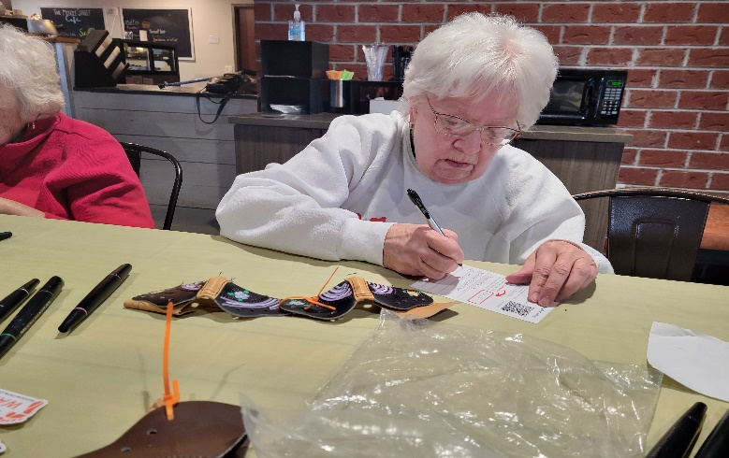Louise Garverick 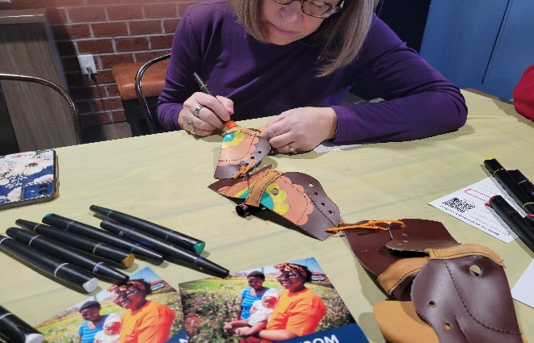Kristine Reynolds
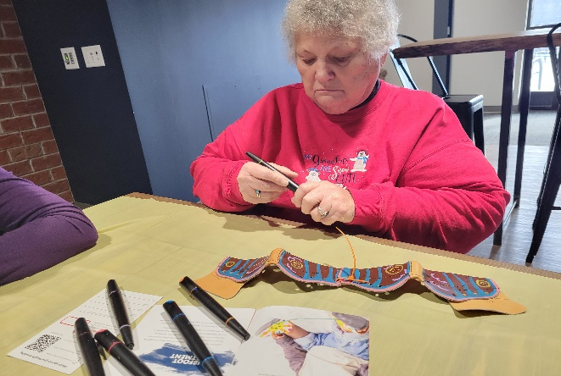
Esther Sanders
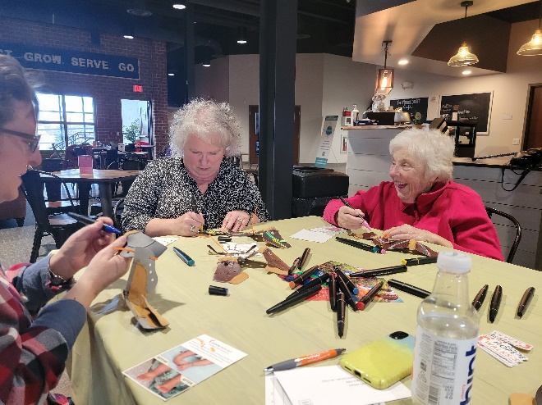
Fran Ruda-McDermott
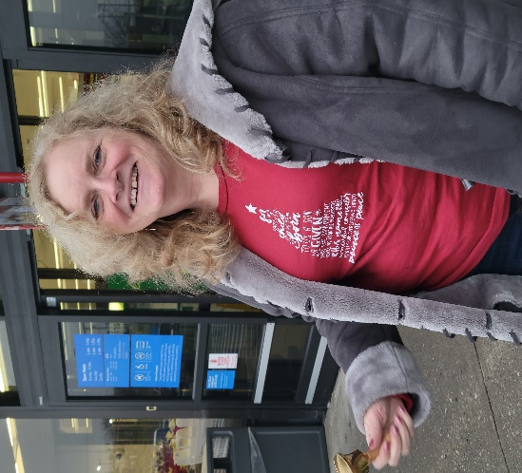
Laura Young and Marg Keller ringing the bells for the Salvation Army-Dec. 2022
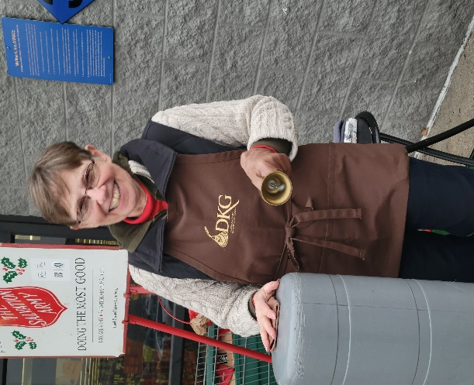
Tammy Deardorff, Brenda Newman, and Frances Bassett ringing bells for the Salvation Army-Dec. 2022
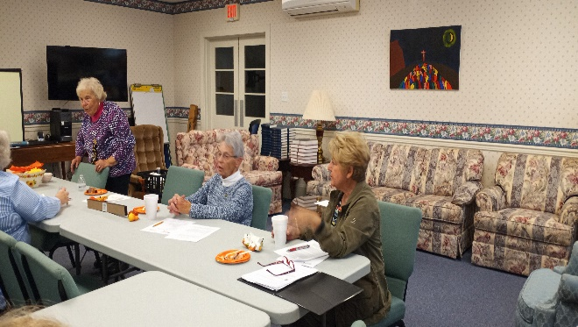
Liz Fair, Barbara Montgomery, and Fran Ruda-McDermott (above) with Barbara Montgomery and Mary Ann Dissinger-Amspacher (below) at our November Meeting
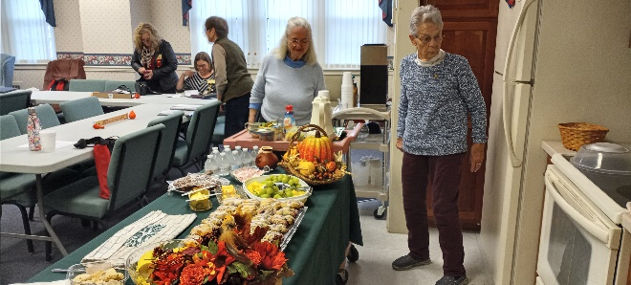
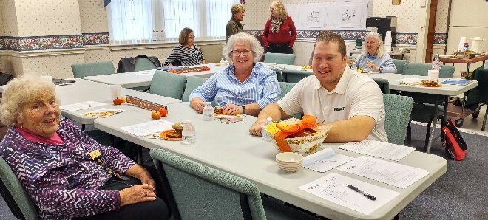
Fran Ruda-McDermott with Joseph Yarish and his mother
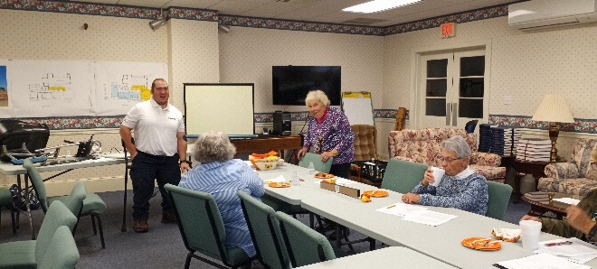
November 2022 Meeting with Joseph Yarish
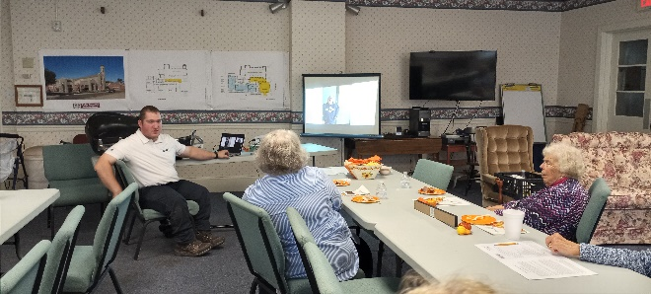
^^^^^^^^^^^^^^^^^^^^^^^^^^^^^^^^^^^
Beta Kappa Spring Membership Meeting
“Wearing of the Green”
March 25, 2023 at 10 AM
Waynesboro Country Club,
11000 Country Club Rd.
Waynesboro, PA
Enjoy an Irish Luncheon
(Guinness Marinated Pork Loin, Parsley Potatoes, Sweet Peas, Spring Salad with choice of dressings, Rolls and Butter, Mint Dessert, and Selected Beverages for a cost of $20.00 inclusive of tax and gratuity)
“MEET and GREET”
with
Author Annilese Grey

DID YOU KNOW?
Members may choose to return their Key Pin to the chapter “when they can no longer wear it”. Below is a form which you may use to let your family know you would like to return your pin to your Beta Kappa Chapter.
++++++++++++++++++++++++++++++++++++
To My Family/Friends,
This is my Delta Kappa Gamma Key Pin. I have worn it with pride since my initiation. When I can no longer wear it, please return it to:
Beta Kappa Chapter or
PA State Organization
To get the name and address of my Chapter’s current president, please contact:
The Delta Kappa Gamma Society International, 12710 Research Blvd. Ste 230, Austin , TX 78767-1589 tel: 512-478-5748, 888-762-4685
Date: _____________________________
Signature: _________________________
++++++++++++++++++++++++++++++++++++

