Beta Kappa BANTER

November 2022-January 2023

Mission Statement: The Delta Kappa Gamma Society International promotes professional and personal growth of women educators and excellence in education.
The Second Purpose of the Delta Kappa Gamma Society will be: To honor women who have given or who evidence a potential for distinctive service in any field of education.

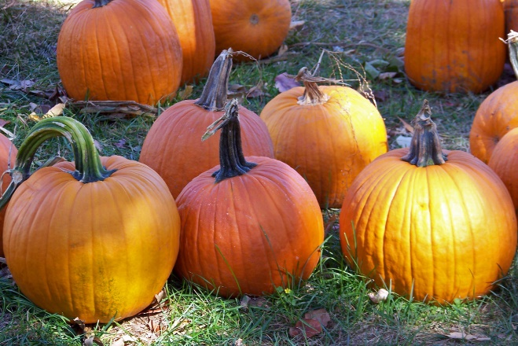
PRESIDENT’S MESSAGE
Greetings, Beta Kappa Sisters!
Now that we’re deep into autumn, our autumn meeting is fast approaching. We will be meeting at Trinity Evangelical Lutheran Church in Chambersburg on Saturday, November 12th at 10 A.M. Our speaker will be Joseph Yarish, a paraplegic due to spina bifida, who will be sharing his challenges and triumphs in his personal and educational life. We will be having some light breakfast items. It is sure to be a great meeting, and I hope you can attend.
At our September 9th meeting, Justine Miller, associate athletic director at Mount Saint Mary’s, talked about her position in which she helps advise and coach student/athletes at the Mount. Since taking her position, the student/athlete average GPA has risen to 3.1, astounding for any college or university. The talk with the following question-and-answer period was not only enjoyable, but so informative. Thanks again to Justine for her willingness to share.
This season also brings us opportunities to do service, a crucial aspect of our society. We will be once again partnering with the Salvation Army to do bell ringing. I will have more information on that on the 12th. We are also planning a Saturday, probably in January or February (with a snow date) to help paint the leather braces needed for children with club feet. The charity involved is called Hope Walks, and it provides children with club feet the chance for corrective surgery and the successive braces until the club foot is cured. It was a charity started locally in Mechanicsburg and has impacted thousands of children worldwide. We will be meeting in the café at Foursquare Church in Gettysburg where we will paint the braces in bright colors to make the wearing of these braces a little easier. I hope to have the exact dates and times for you at the next meeting.
As this is the last newsletter before the holidays, may you all have a blessed holiday season, and may we have a great 2023 to come.
Laura

__________________________________
November GENERAL MEMBERSHIP MEETING
Our next chapter meeting will be held on November 12th from 10AM to 12 noon at Trinity Evangelical Lutheran Church. Our speaker, Joseph Yarish, will talk about his life and accomplishments while living with spina bifida. A light breakfast will be served prior to the business meeting.

It’s Salvation Army Bell Ringing Time Again!
More details to follow…If you are interested in supporting this important project, please reach out to Laura Young or Tammy Deardorff.
***********************************
November
19 – Krisitine Reynolds
28 – Angela Eisenhart

December
18 – Anita Shultz
27 – Beverly Utz
31 – Esther Sanders

January
7 – Gretchen Mackey
21 – Jennifer Kane

International Website:
https://dkg.org
Pennsylvania State Website:
https://dkgpa.weebly.com
Beta Kappa Website:
https://betakappapa.weebly.com

++++++++++++++++++++++++++++++
2022-2024 Biennium Officers:
President-Laura Young
First Vice Pres.-Fran Ruda-McDermott
Second Vice Pres.-Liz Fair
Recording/Corresponding Secretary-Tammy Deardorff
Treasurer-Kristine Reynolds
Parliamentarian-Jill Miller

IMPORTANT DATES TO REMEMBER
November 12, 2022 Chapter Meeting at Trinity Evangelical Church, Chambersburg, PA
January 21, 2023 Executive Committee-Apple Bin, Biglerville, PA (Snow date January 28, 2023)
March 25, 2023 Chapter Meeting- West Side
April 21-23, 2023 Creative Arts Retreat-Camp Ladore, Waymart, PA
June 2023 Beta Kappa/Omega Chapters’ Picnic-East Side
June 2023 PA State Convention

+++++++++++++++++++++++++++++++++++++++++++++++
Special Committee Chairpersons 2022-2024
Communications: Deborah Yargar-Reed
Finance: Marge Keller
Historical Records: Kristine Reynolds, Bev Utz
Membership: Liz Fair
Newsletter: Tammy Deardorff, Brenda Newman
Nominations:
Scholarship: Sally Becker, Carol Hozman
Welfare: Gayle Griffie, Jill Miller
U.S. Forum/Legislative: Karen Locke
World Fellowship: Peg Lady
************************************
Photo Gallery…
September 9, 2022
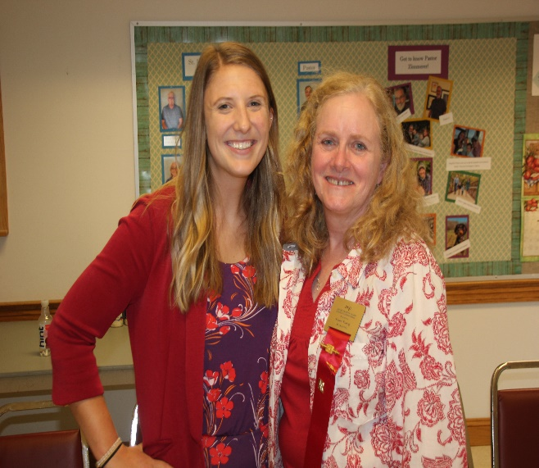
Justine Miller and Laura Young at the September Meeting
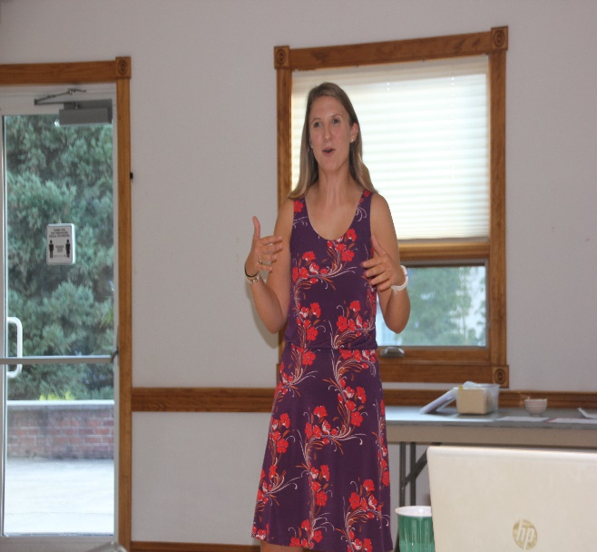
Justine Miller

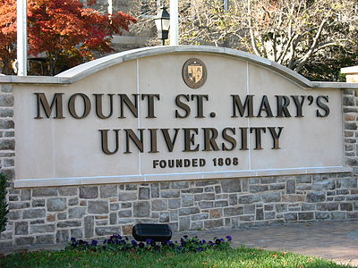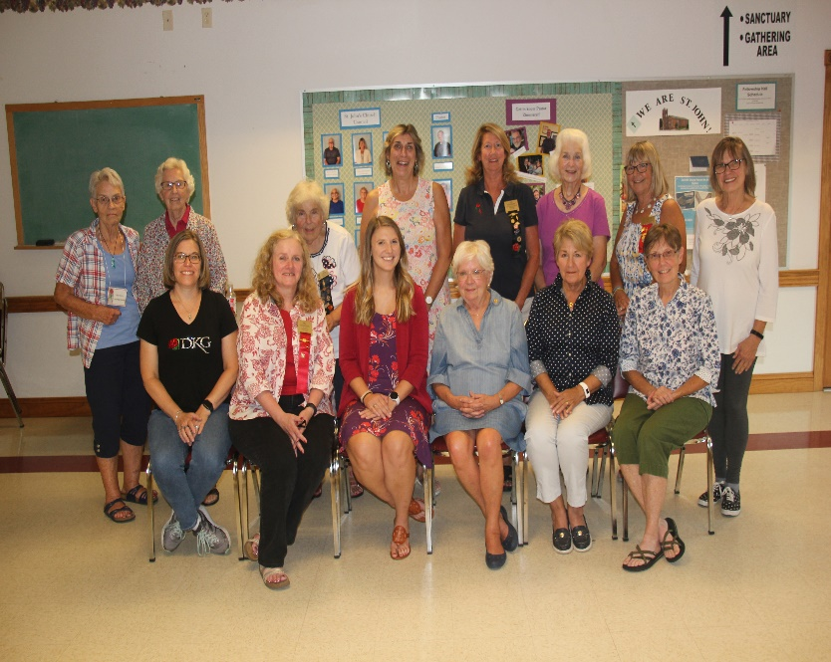

Beta Kappa Members at the September General Membership Meeting

